Name: ___________________________

Tier 1 Quia Unit 4 Cheat Sheet

There will be Quia assignments to complete almost every week of the quarter.
We will go over the material in class so that you understand how to complete the homework. DO NOT LOSE THIS PACKET. You WILL NOT be given another packet if you lose this one, it will be your responsibility to take notes on the new information.

I recommend using this packet to help you do your quia homework! This is supposed to be a tool that will help you!

Unit 4 Week 1:
Information: Rhythm Level 3A (dotted quarter note, eighth note counting)

Adding a dot to a note:
______________________________________________________________________________
______________________________________________________________________________
______________________________________________________________________________
Note Name: _______________________________
Note Duration: _____________________________

=

Rhythm Counting – Fill in the counts for the following examples:
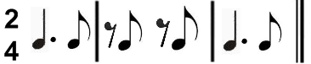

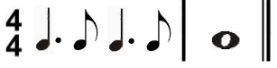

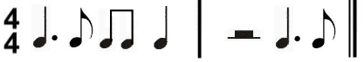

Unit 4 Week 2:
Information: 1st/2nd endings

WHAT IS THE NAME OF THE FOLLOWING SYMBOL?
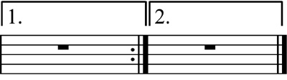

WHAT IS THE NAME OF THE FOLLOWING SYMBOL?

WHAT HAPPENS WHEN YOU SEE BOTH SYMBOLS TOGETHER?
_______________________________
_______________________________
_____________________________________________________________________________________
_____________________________________________________________________________________
_____________________________________________________________________________________

Unit 4 Week 3:
Information: Natural, DC/DS al Coda

NAME OF SYMBOL: __________________________________________________

WHAT DOES SYMBOL DO? _____________________________________________

____________________________________________________________________

D.C. STANDS FOR: _____________________________________________________________________

D.S. STANDS FOR: _____________________________________________________________________

CODA MEANS: _______________________________________________________________________

_____________________________________________________________________________________
D.C. AL CODA MEANS: __________________________________________________________________

_____________________________________________________________________________________

D.S. AL CODA MEANS: __________________________________________________________________

_____________________________________________________________________________________

Unit 4 Week 4:
Information: Rhythm Level 5

DEFINITION OF TIE:

_____________________________________________________________________________________
_____________________________________________________________________________________
_____________________________________________________________________________________
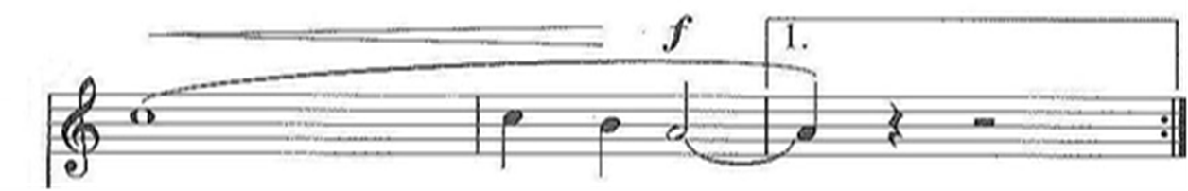
CIRCLE THE TIE IN THE FOLLOWING EXAMPLE:

IN EACH BOX WRITE IN HOW MANY COUNTS THE FOLLOWING EXAMPLES RECEIVE:

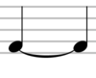
=
=

=

WRITE IN THE COUNTS FOR THE FOLLOWING RHYTHM EXAMPLES:
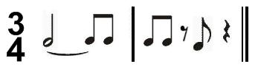

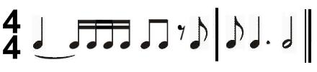

Unit 4 Week 5:
Information: 8th note triplet, Rhythm Level 6

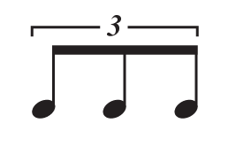
Note Name: _______________________________________

Note Value: ______________________________________

=

Write in the counts for the following examples.
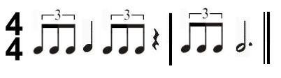

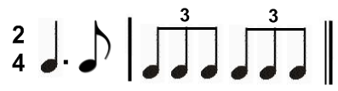

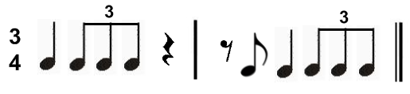

Unit 4 Week 6:
Information: Quarter Review
Unit 4 Week 7:
Information: Year Review
Unit 4 Week 8:
TEST

