Name: ___________________________

Tier 2 Quia Unit 4 Cheat Sheet

There will be Quia assignments to complete almost every week of the quarter.
We will go over the material in class so that you understand how to complete the homework. DO NOT LOSE THIS PACKET. You WILL NOT be given another packet if you lose this one, it will be your responsibility to take notes on the new information.

I recommend using this packet to help you do your quia homework! This is supposed to be a tool that will help you!
Unit 4 Week 1:
New Information: 6/8 Level 1 Counting

WRITE HOW MANY BEATS PER MEASURE AND WHAT NOTE GETS THE BEAT IN THE BOX BELOW

WHAT VALUE DO NOTES RECEIVE IN 6/8?

=
=

=
=

FILL IN THE COUNTS FOR THE FOLLOWING EXAMPLES:
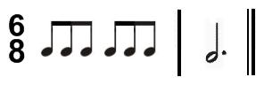

_______________________________________________________

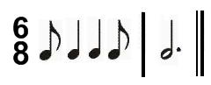

_____________________________________________________
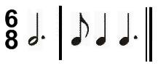

_______________________________________
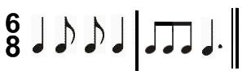

______________________________________________________________

Unit 4 Week 2:
New Information: Natural

WHAT DO WE CALL THIS SYMBOL? __________________________________

WHAT DOES A NATURAL DO TO A NOTE? _____________________________
______________________________________________________________________________
______________________________________________________________________________

Unit 4 Week 3:
New Information: Rhythm Counting Level 6B
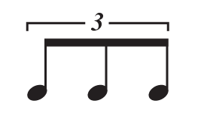
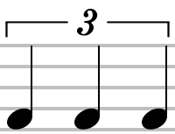
What is the difference between and ?

_____________________________________________________________________________________
_____________________________________________________________________________________
Note Name: ______________________________________

Note Value: ______________________________________

=

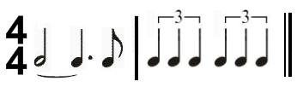
Write in the counts for the following examples.

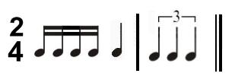

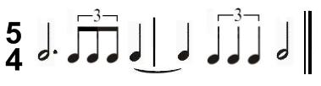

Unit 4 Week 4:
New Information: Level 6 Counting Review

Unit 4 Week 5:
New Information: Sharp/flat key signature review
Unit 4 Week 6:
New Information: 6/8 Level 2 Counting

WHAT VALUE DO RESTS RECEIVE IN 6/8?

=
=

=

=

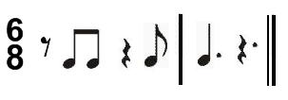
FILL IN THE COUNTS FOR THE FOLLOWING EXAMPLES:

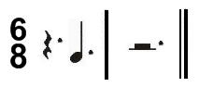

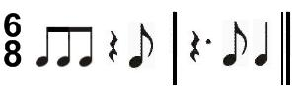

Unit 4 Week 7:
4th quarter Review

Unit 4 Week 8:
TEST

