Name: ___________________________

Tier 4 Quia Unit 4 Cheat Sheet

There will be Quia assignments to complete almost every week of the quarter.
We will go over the material in class so that you understand how to complete the homework. DO NOT LOSE THIS PACKET. You WILL NOT be given another packet if you lose this one, it will be your responsibility to take notes on the new information.

I recommend using this packet to help you do your quia homework. This is supposed to be a tool that will help you!

Unit 4 Week 1
New Information: Triplet, Rhythm Counting Level 6, Cesura, Fermata
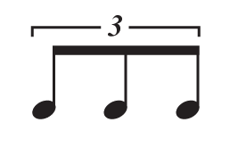
Note Name: _______________________________________

Note Value: ______________________________________

=

Write in the counts for the following examples.
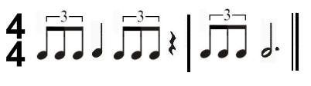

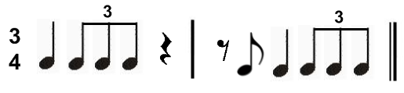

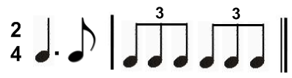

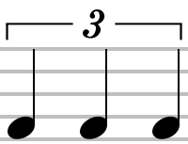

What is the difference between and ?

_____________________________________________________________________________________
_____________________________________________________________________________________
_____________________________________________________________________________________
Note Name: ______________________________________

Note Value: ______________________________________

=

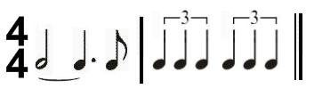
Write in the counts for the following examples.

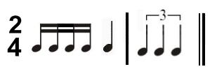

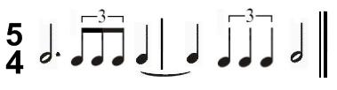

NAME OF SYMBOL: __________________________________________
WHAT DOES SYMBOL DO? ___________________________________
______________________________________________________________
____________________________________________________________________________________
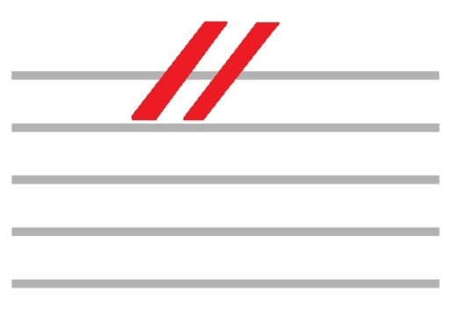

NAME OF SYMBOL: __________________________________
WHAT DOES SYMBOL DO? ____________________________
______________________________________________________
______________________________________________________

Unit 4 Week 2
New Information: Natural Accidentals

WHAT DO WE CALL THIS SYMBOL? __________________________________

WHAT DOES A NATURAL DO TO A NOTE? _____________________________
______________________________________________________________________________
IF B-FLAT WAS “DO” THEN B-NATURAL WOULD BE ____________
WHY? ________________________________________________________________________________
_____________________________________________________________________________________
IF E-FLAT WAS “SOL”, THEN E-NATURAL WOULD BE ___________
WHY? ________________________________________________________________________________
_____________________________________________________________________________________
IF C-SHARP WAS “MI”, THEN C-NATURAL WOULD BE __________
WHY? ________________________________________________________________________________
_____________________________________________________________________________________

FILL OUT THE FOLLOWING SOLFEGE EXAMPLES

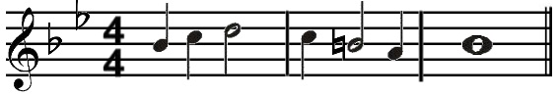

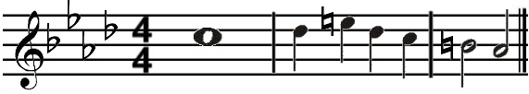
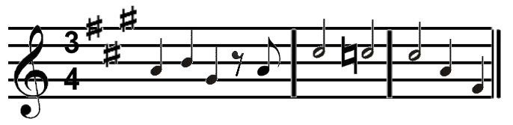

Unit 4 Week 3
New Information: Rhythm Counting with pick ups

DEFINE PICK UP: _______________________________________________________________________
_____________________________________________________________________________________

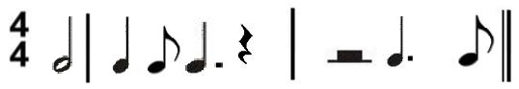

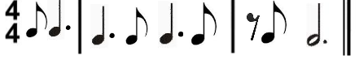

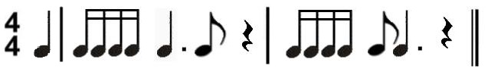

Unit 4 Week 4
New Information: Rhythm Counting Level 7

WRITE OUT THE COUNTS FOR THE SIXTEENTH NOTES
=

WRITE IN THE COUNTS FOR THE FOLLOWING RHYTHMS

=

=

=

WRITE IN THE COUNTS FOR THE FOLLOWING EXAMPLES
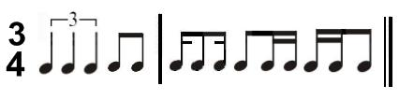

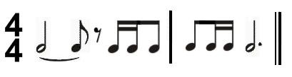

Unit 4 Week 5
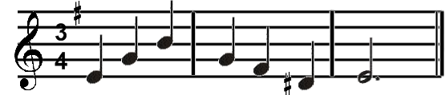
New Information: Mixed Accidental Solfege
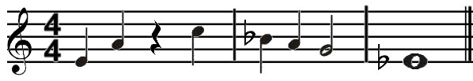
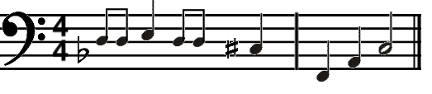

Unit 4 Week 6
New information: Voice Parts

SOME MUSIC IS WRITTEN IN SATB FORMAT…
THE “S” IN SATB STANDS FOR ____________________________________
THE “A” IN SATB STANDS FOR ____________________________________
THE “T” IN SATB STANDS FOR _____________________________________
THE “B” IN SATB STANDS FOR _____________________________________
SOME MUSIC IS WRITTEN IN SAB FORMAT…
THE “S” IN SAB STANDS FOR _____________________________________
THE “A” IN SAB STANDS FOR _____________________________________
THE “B” IN SAB STANDS FOR _____________________________________

THE _________________________ IS THE HIGHER FEMALE VOICE.
THE _________________________ IS THE LOWER FEMALE VOICE
THE ___________________________ IS THE HIGHER MALE VOICE
THE ___________________________ IS THE MIDDLE MALE VOICE
THE ___________________________ IS THE LOWER MALE VOICE

IN THREE AND FOUR PART MUSIC, THIS CLEF IS TYPICALLY USED FOR ______________________ AND ______________________.

IN FOUR PART MUSIC, THIS CLEF IS TYPICALLY USED FOR __________________________.

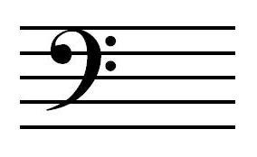
IN THREE PART MUSIC, THIS CLEF IS TYPICALLY USED FOR ____________________________.
IN FOUR PART MUSIC, THIS CLEF IS TYPICALLY USED FOR ____________________________.

Unit 4 Week 7
REVIEW

Unit 4 Week 8
TEST

